**Test Execution Log and Screenshots**

|  |  |
| --- | --- |
| **Test Script ID** | TEST01 |
| **Test Script Description** | TEST01_Launch Cyclos and Perform a Payment to system |
| **Executed by** | Testing |
| **Executed Date & Time** | 07/31/2018 3:40:41 PM |
| **Test Status** | **Failed** |

Step Name: Step Name: Step_1   
Step Details: Click Signin button  
Expected Result: Signin button should be clicked  
Actual Result: Signin button is clicked  
Result: Passed

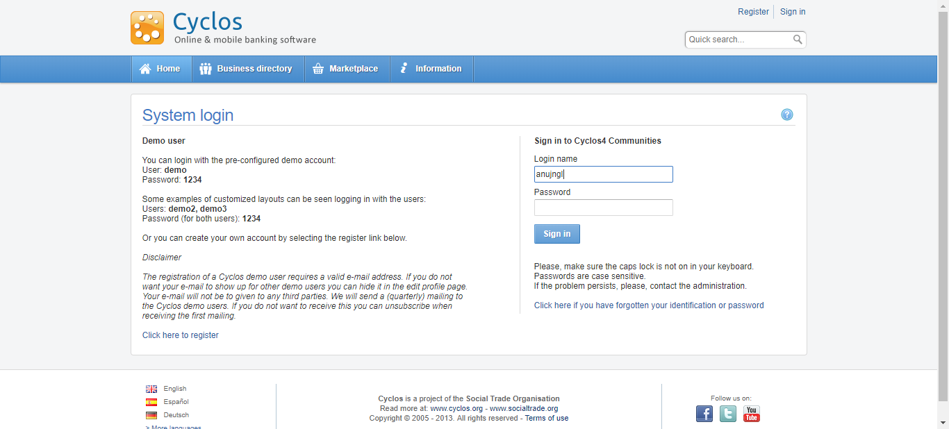

Step Name: Step Name: Step_2   
Step Details: Enter UserName  
Expected Result: Username should be entered  
Actual Result: Username is entered  
Result: Passed



Step Name: Step Name: Step_3   
Step Details: Enter Password  
Expected Result: Password should be entered  
Actual Result: System encountered a failure while trying to enter the data Soft2017 into the web element, Reason:Expected condition failed: waiting for element to be clickable: By.xpath: //*[@id='password'] (tried for 3 second(s) with 500 milliseconds interval)  
Result: Failed

